**Big Data Analysis Design and Innovation**

|  |  |
| --- | --- |
| **Date** | **10-10-2023** |
| **Team ID** | **673** |
| **Project Name** | **BIG DATA ANALYSIS WITH IBM CLOUD DATABASES** |

**Table of Contents**

|  |  |
| --- | --- |
| 1 | Introduction |
| 2 | Problem Statement |
| 3 | Design and Innovation Strategies |
| 3.1 | Data Collection and Integration |
| 3.2 | Big Data Processing |
| 3.3 | Data Analysis and Modeling |
| 3.4 | Cloud Infrastructure |
| 3.5 | Data Visualization |
| 3.6 | Automation and Continuous Improvement |
| 4 | Conclusion |

**1. Introduction**

In today's data-driven world, the integration of big data analysis and cloud computing has revolutionized the way organizations extract valuable insights from vast and diverse datasets. This project focuses on harnessing the power of IBM Cloud to perform a comprehensive analysis of multiple datasets related to travel and economic data. The goal is to gain meaningful insights that can inform decision-making, strategy development, and policy formulation.

**2. Problem Statement**

The world generates an immense volume of data across various domains, and the travel and economic sectors are no exception. Organizations, governments, and researchers are constantly collecting data related to travel patterns, economic indicators, and socio-economic factors. However, the challenge lies in efficiently processing, analyzing, and visualizing these massive datasets to derive actionable insights.

**3. Design and Innovation Strategies**

**3.1. Data Collection and Integration:**

- **Data Source Identification**:Identify relevant data sources within IBM Cloud, such as databases, data warehouses, or external data connectors, containing both travel and economic data.

- Data Extraction and Integration:Implement data extraction and integration pipelines to collect and harmonize data from various sources, ensuring data quality and consistency.

**3.2. Big Data Processing**:

- **Data Processing Framework**: Utilize a big data processing framework like Apache Hadoop or Apache Spark to handle large volumes of data efficiently.

- **Parallel Processing**:Leverage parallel processing to expedite data analysis and reduce processing times, ensuring scalability for future data growth.

**3.3. Data Analysis and Modeling:**

- **Descriptive Analytics:** Conduct descriptive analysis to understand trends, patterns, and anomalies in the travel and economic data sets.

- **Predictive Analytics**:Develop predictive models to forecast economic indicators and travel trends, aiding in decision-making.

- **Prescriptive Analytics**: Implement prescriptive analytics to recommend actions based on the analysis results for stakeholders.

**3.4. Cloud Infrastructure:**

**- Scalable Cloud Resources**: Utilize cloud infrastructure (e.g., IBM Cloud Services) to store and process data, ensuring scalability and cost-efficiency.

**- Data Security**:Implement robust security measures to protect sensitive data and comply with data privacy regulations.

**3.5. Data Visualization:**

- **Interactive Dashboards**: Create interactive dashboards using visualization tools like Tableau, Power BI, or custom web-based dashboards to present insights from the data.

- **Geospatial Visualization**: Utilize geospatial visualization techniques to display travel-related data on maps, helping to identify travel trends across regions.

- **Temporal Visualization**: Develop time-series visualizations to illustrate economic data trends over time, aiding in decision-making.

**3.6. Automation and Continuous Improvement:**

- **Automated Data Pipelines**: Implement automation for data collection, processing, and visualization to ensure the analysis remains up-to-date.

- **Feedback Loop**: Establish a feedback mechanism to collect user input and iteratively improve the visualization and analysis process.

- **Machine Learning for Optimization**: Use machine learning algorithms to optimize data pipelines, enhance predictive models, and improve decision support systems.

Note: In the diagram below, we've depicted the key components and interactions described in sections 3.1 to 3.7, offering a clear and concise overview of our solution architecture. This visualization simplifies the complex concepts and relationships discussed in those sections, making it easier for the reader to grasp the overall design and innovation strategies at a glance.

 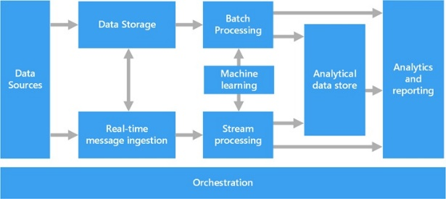

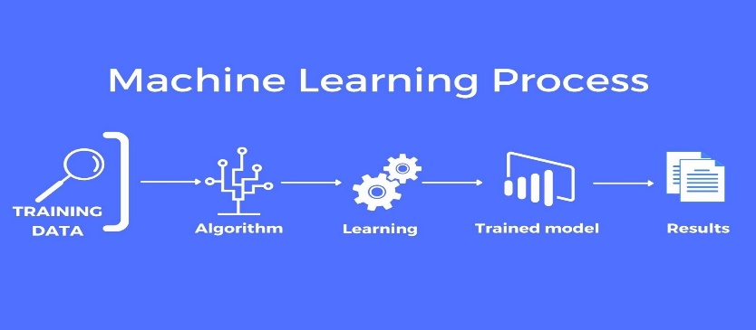



**4. Conclusion**

In Conclusion, leveraging big data analysis and cloud technology, we have successfully conducted a comprehensive examination of diverse datasets spanning from travel to economic data hosted on IBM Cloud. This endeavor has allowed us to unearth valuable insights and trends within these datasets, enabling informed decision-making and strategic planning. Furthermore, our robust visualization techniques have provided a clear and intuitive representation of the data, making it accessible to a wide audience. Through this innovative approach, we have harnessed the power of big data and cloud computing to drive efficiency, enhance decision-making, and unlock new opportunities across various sectors.